Journey Through The Bible

**JESUS**

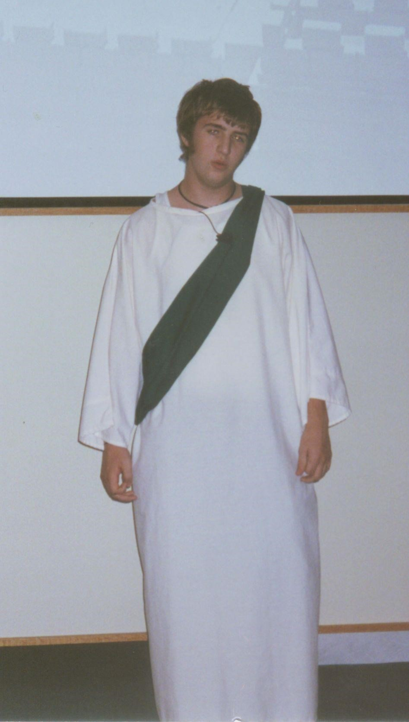

Luke 2:41-52

My name is Jesus and I am 12 years old. Every year my parents go to Jerusalem for the Feast of the Passover. I was considered almost an adult at 12 and so I didn't spend a lot of time with my parents. After the feast was over, my parents were returning home, but I stayed behind in Jerusalem, but they didn't know it. They thought that I was traveling with their group. It was a full day before they realized that I was not with their group. They went from group to group asking their relatives and friends, have you seen Jesus? They couldn't find me anywhere. They decided to return to Jerusalem to try and find me. They looked everywhere and really began to worry when finally on the third day they found me in the temple courts. The temple was famous throughout Judea as a place of learning. The greatest rabbis of the land would assemble to teach and to discuss great truths among themselves. I was sitting among the teachers, listening to them and asking them questions. Everyone seemed astonished with my answers and my understanding of what they were discussing. When Mother and Father found me they were surprised. Mother said, "Jesus, why have you treated us like this? Your father and I have been anxiously searching for you."

I asked, "Why were you searching for me?" Didn't you know that I had to be in my Father's house? They knew I was talking about God's house. This was the first time that the Bible mentions I was aware that I was God's Son. Mother and Father didn't seem to understand what I said to them. They had raised me, along with my brothers and sisters as a normal child. They knew that I was unique, but they did not know what was going on in my mind.

I then left the temple and went to Nazareth with them. I obeyed them. My mother was really proud of me in her heart. I continued to learn and mature as I lived with my parents for the next 18 years. The Bible says that I grew in wisdom and stature, and in favor with God and men.

Memory Verse: **Luke 11:9**

☼ Ask, and it will be given to you; seek, and you will find.

What did you learn from this lesson? ☺ You must do God’s will to please Him as Jesus did.

Do you know? **Answer on back page**

**?** **Where did Joseph and Mary find Jesus?**

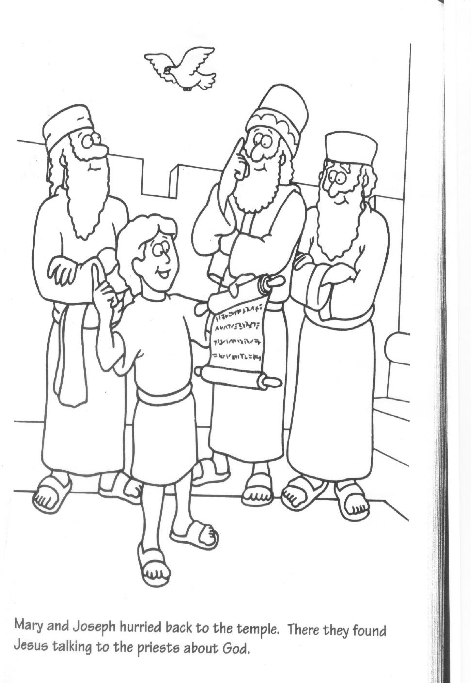

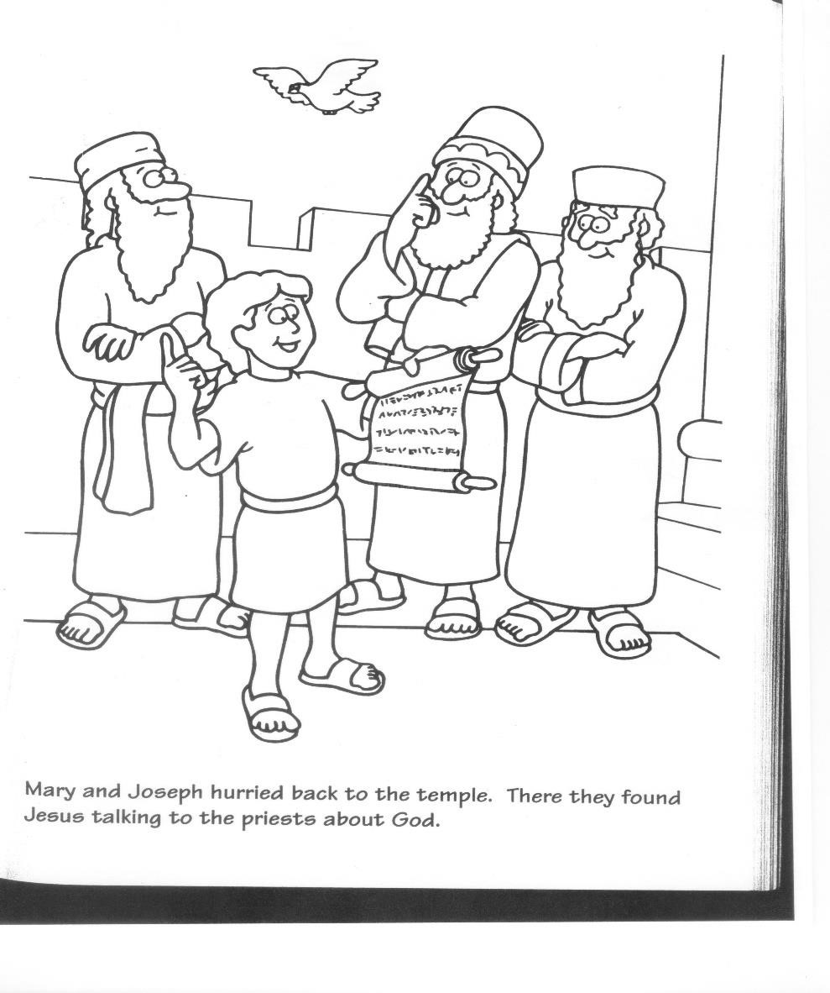

**? Answer to do you know.**

**● In the temple.**